Personal Development Report

Part A- Introduction

A1) The test i completed are

1. Personal Values Assessment (Barrett Values Centre) <https://personalvalu.es/results/b81c3e89-700c-4dc1-8042-2cf79b1a6f63>
2. Work Values Test <https://www.123test.com/report/G8YVCLBAIUUCVTKDKQ/>
3. Free Online Career Test

<https://www.careerfitter.com/free_test/careerbuilder/results>

1. Vark Learning Style Questionnaire https://vark-learn.com/the-vark-questionnaire/?p=results
2. The Big Five Personality Test https://www.outofservice.com/bigfive/
3. Interpersonal Skills Self-Assessment <https://www.skillsyouneed.com/quiz/343479>

A2) The test allows one to have self-reflection and is equally helpful in identifying themselves more and learning who they are. It also encourages them to improve their relationship with the people they surround. The first test, the personal values assessment (Barrett value center), allows knowing about important values for each individual. For instance, after replying to all the questions provided, my result was equivalent to the one in which I am more family-oriented. It means I care for my loved ones, which I agree with because when it comes to my family, I would always be willing to sacrifice my personal needs. It also evaluates the strength and dangers that an individual can face, which is very helpful in getting to know ourselves more.

The three things that a person can learn from taking the assessment are. First, they can judge themselves. Therefore, they are more self-aware. It allows them to understand their strengths and weaknesses and their values and personality. Secondly, it helps to develop a career path; for instance, the work value test identifies where they need more improvement and leads them to success. Lastly, carrying out these assessments helps an individual to have measurable goals. They can set goals freely and achieve them by improving where they are currently lacking.

A3) In the course “understanding workplace behavior,” self-assessment is an essential tool because it helps an individual to understand their preferences, like how they behave at work and what kind of people they want to work with, as well as if they are lacking somewhere how they can adapt themselves and change themselves according to the situation they are facing. For instance, the question like “do you feel you use your emotional thinking more or critical thinking more?” helps the individual to decide whether they are more of a person who would make their decision based on their moral codes or they would make a decision based on their emotional stability. Therefore by knowing their preferences, they can improve their personality, workplace behavior, and even their interpersonal skills and they can be a step closer to their success

A4) Lastly, a self-assessment can help me choose a career because there are various kinds of assessment. It helps me identify my abilities, personality, and work preference. As I gather this information, it helps me determine which job suits me best. For example, I am an extroverted person but also like a quiet working environment when I am on my own. This shows that I can be a team player but also work effectively when I am in my own space. Self-assessment could also help me improve myself as the information suggests where I have to improve my skills, my current strengths, and how I can use them for my future purpose. For instance, my interpersonal skills are average, so I have to improve my communication skills.

Part B- Self- Assessment Scores/Reports:

B1

(A) I agree because I am family-oriented and will do everything to satisfy my family's needs. Still, I also prioritize my health and wealth and, at the same time, value my creativity, and I am always excited and curious to learn about new things.

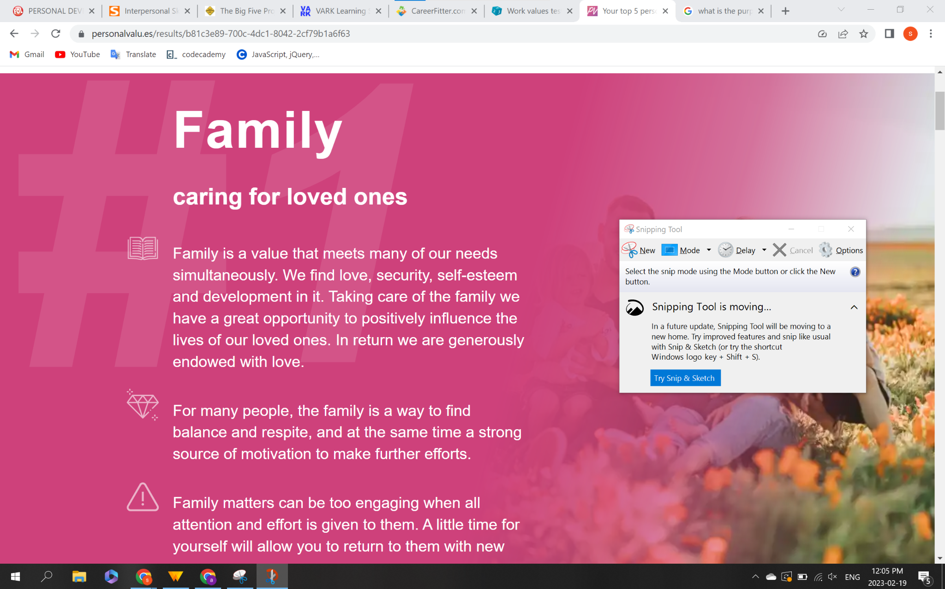

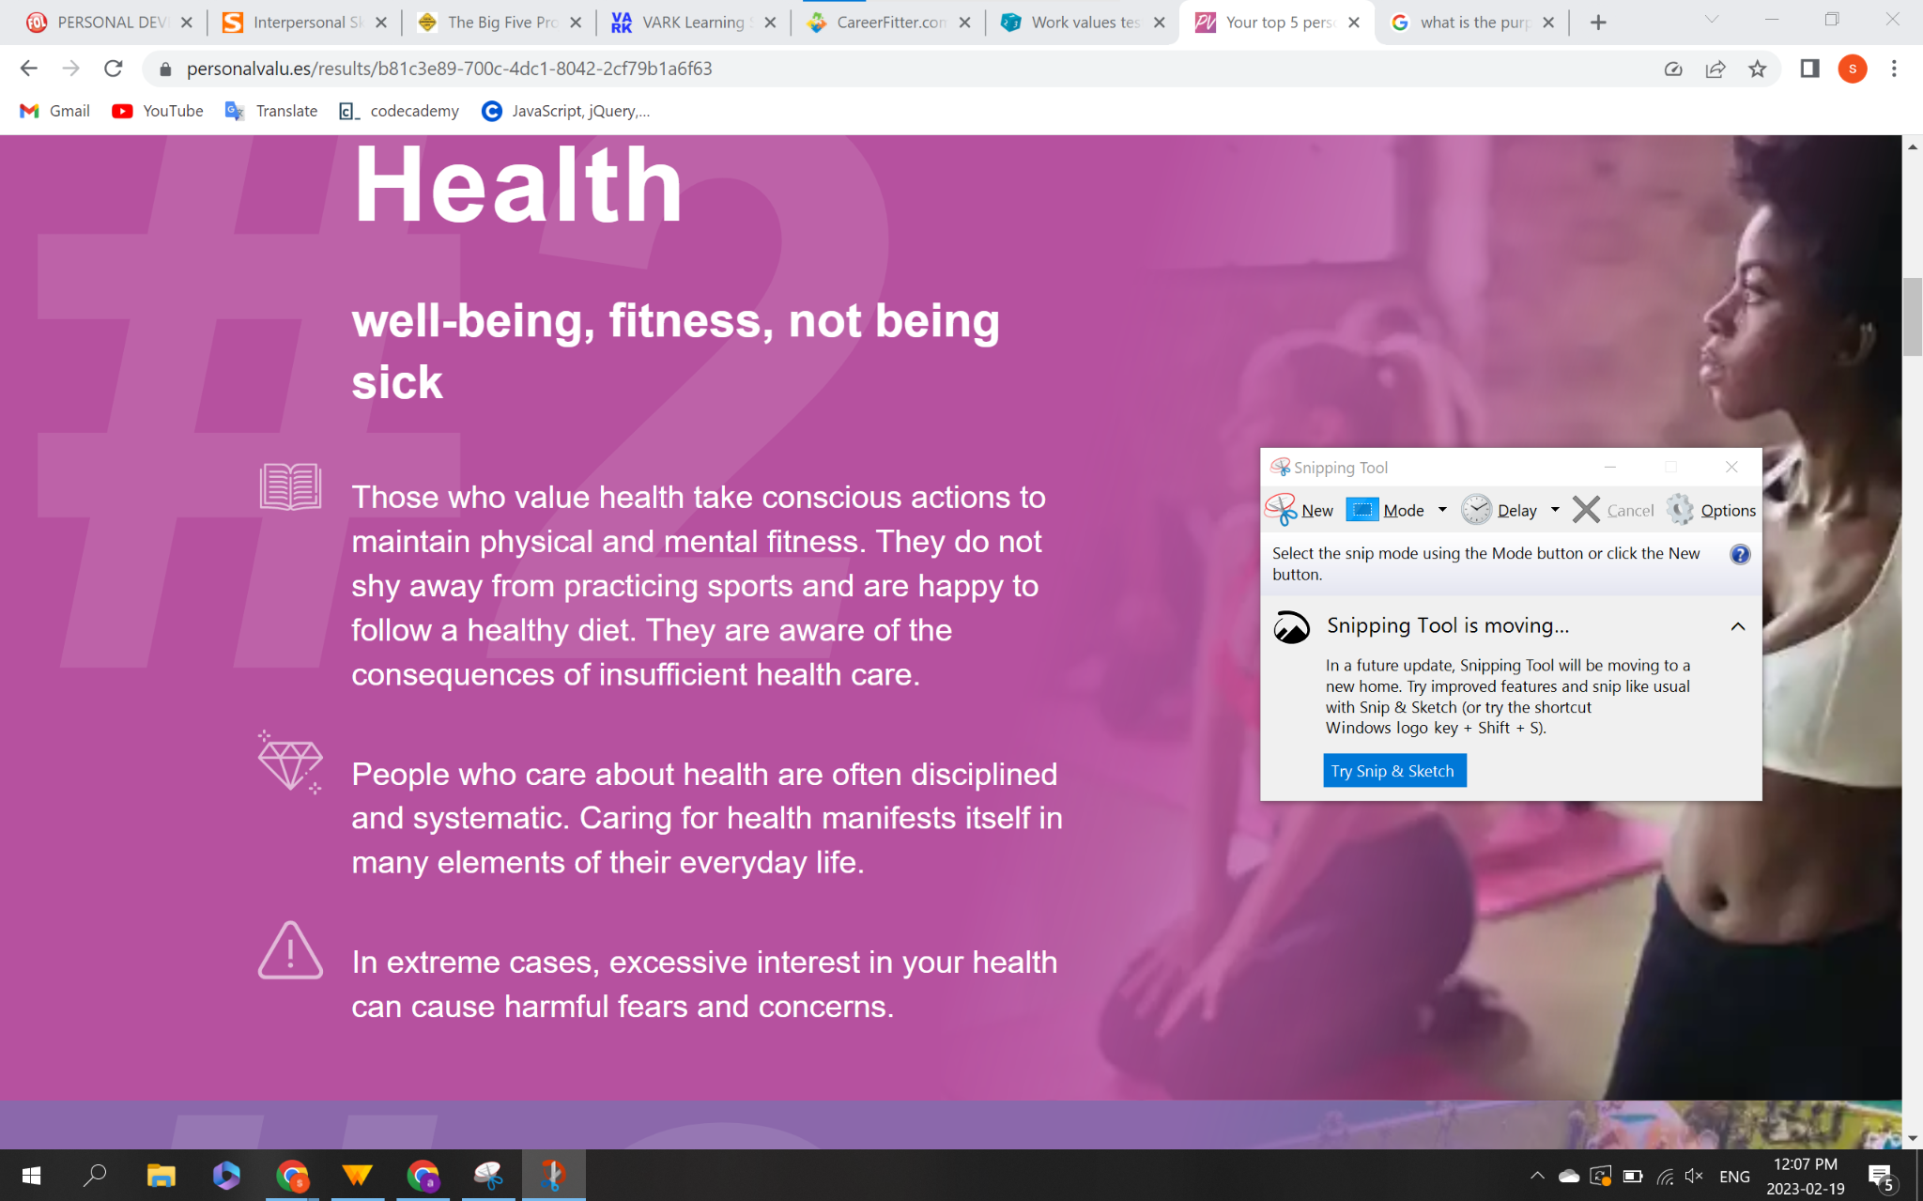

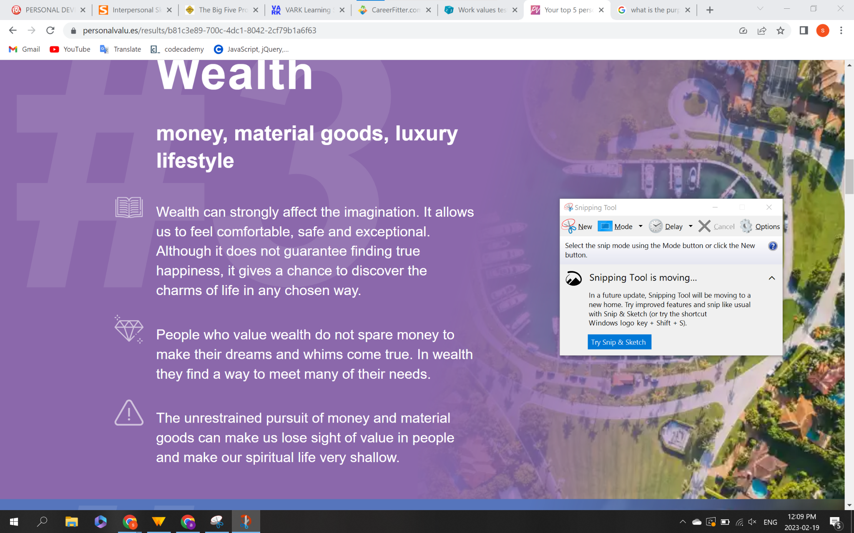

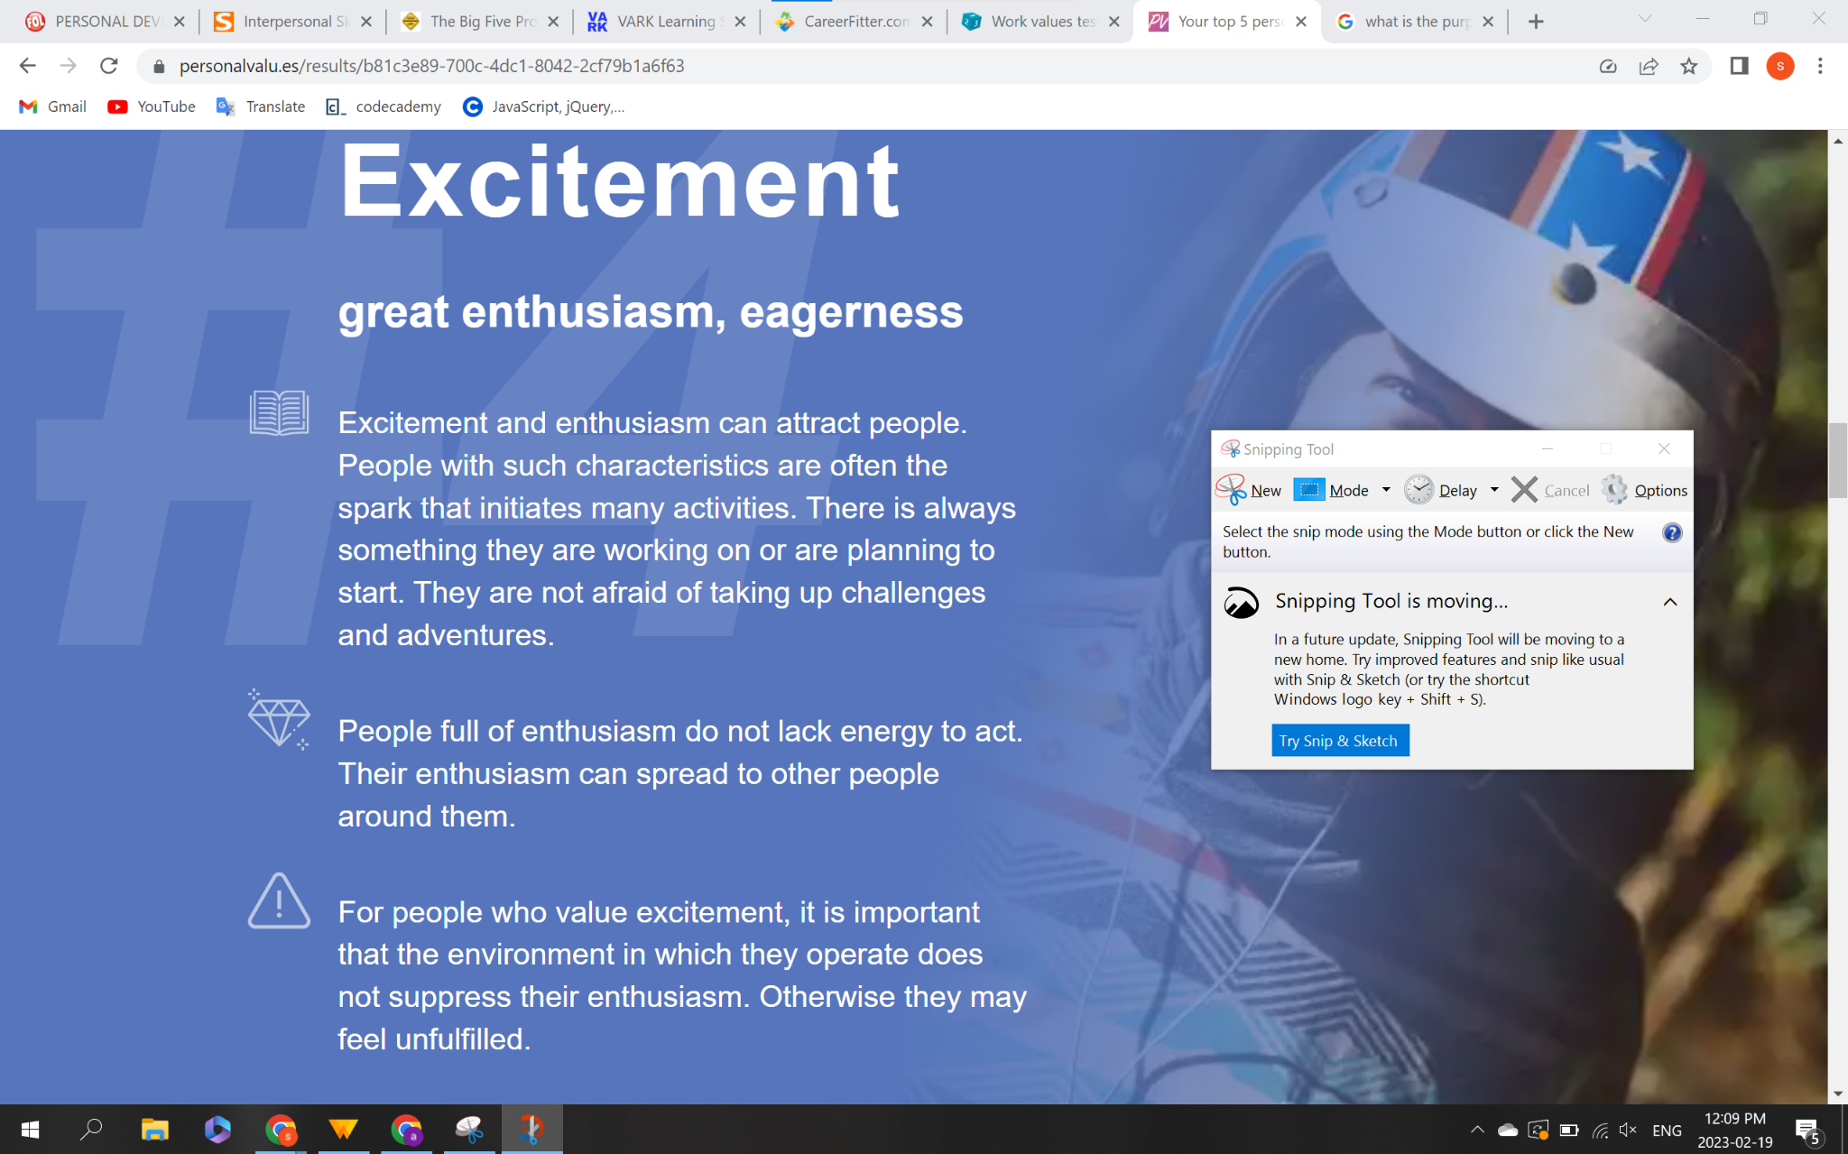

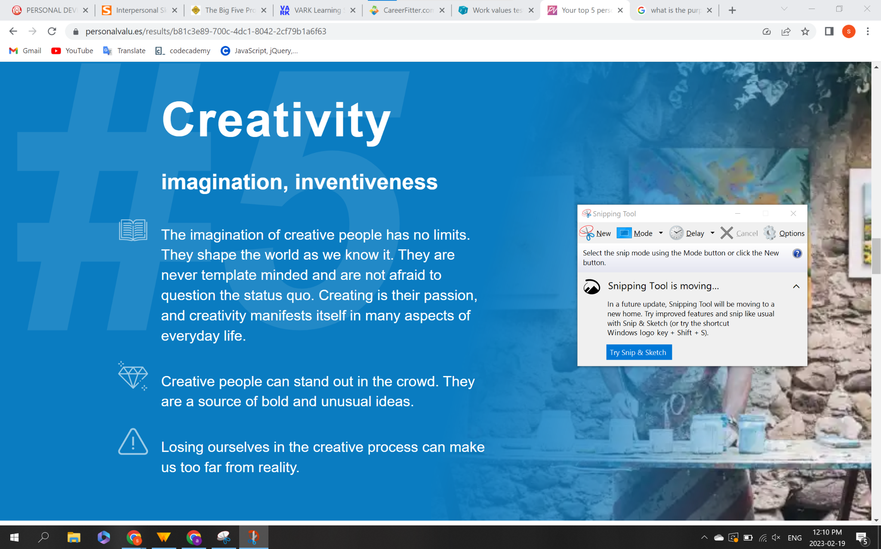

B2

A- This test shows that I have high creativity skills and the ability to influence others which I agree with because I am a person who always comes up with innovative ideas and never hesitates to share them.

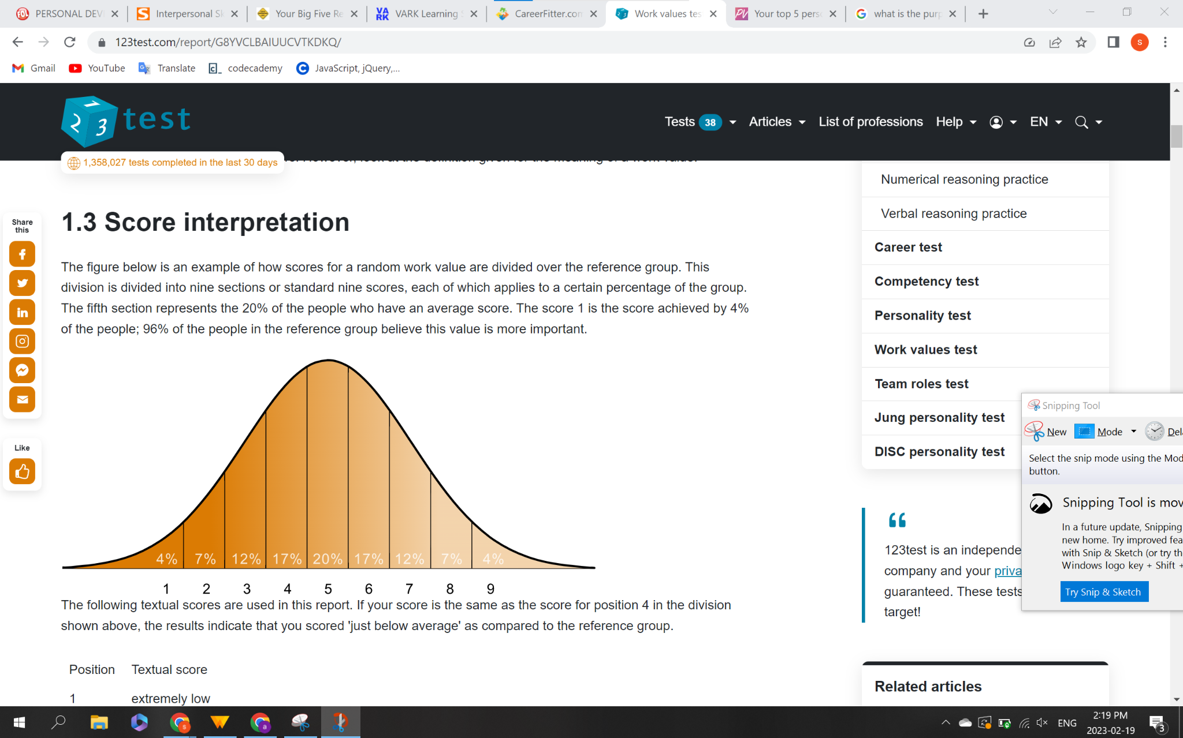

B3

A- I agree with this because it is true that I always seek a career that provides freedom and independence, and also, at the same time, I love seeking new challenges.

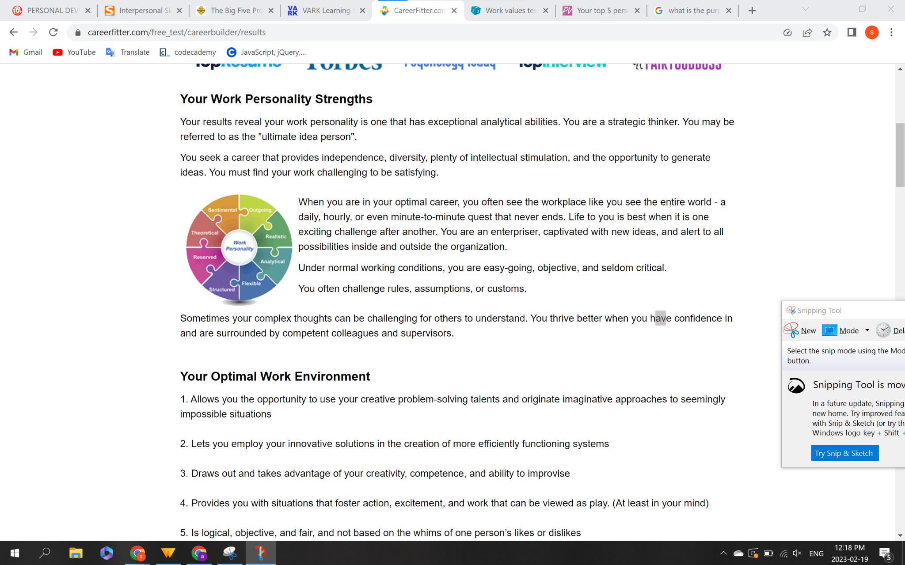

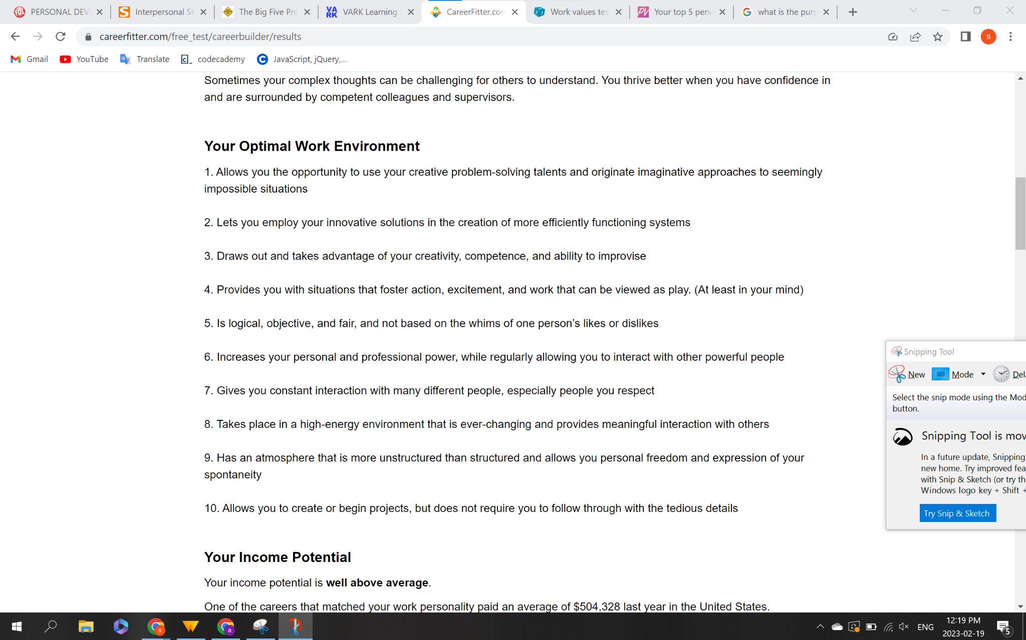

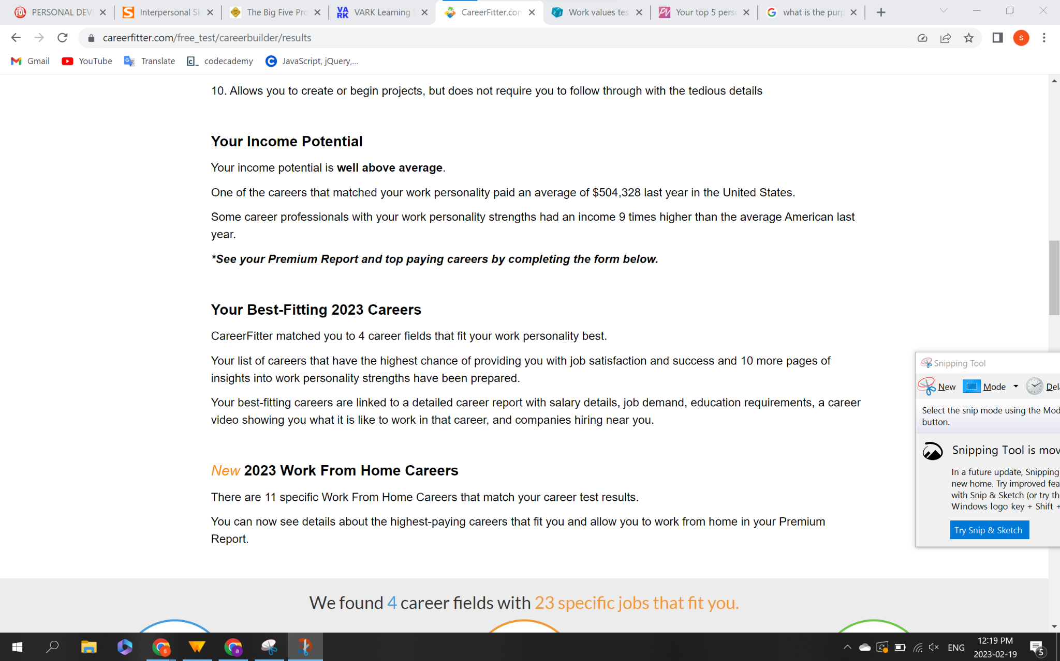

B4

A- In the VARK result, it is also true that when it comes to know about new things, I prefer word of mouth and visuals to gain knowledge of something

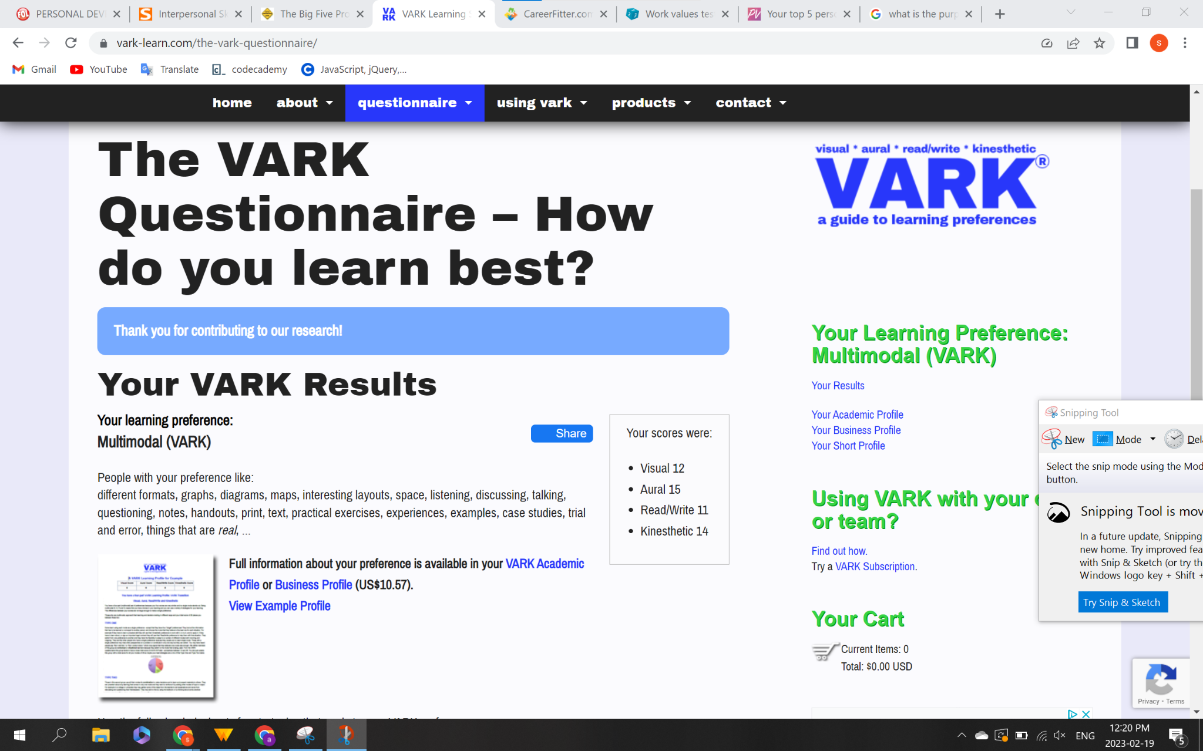

B5

D- I am open-minded and constantly seek new things like, for instance, technology, and I usually give myself a chance to learn every day.

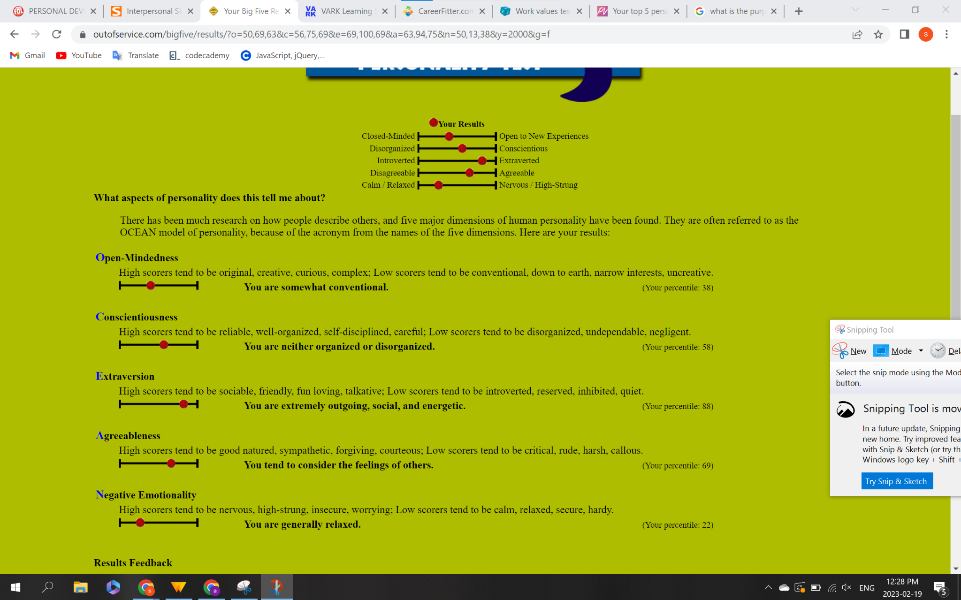

B6

A- I agree with this test because, as a result, it is true that I have picked up bad listening habits, and I want to improve myself in this situation.

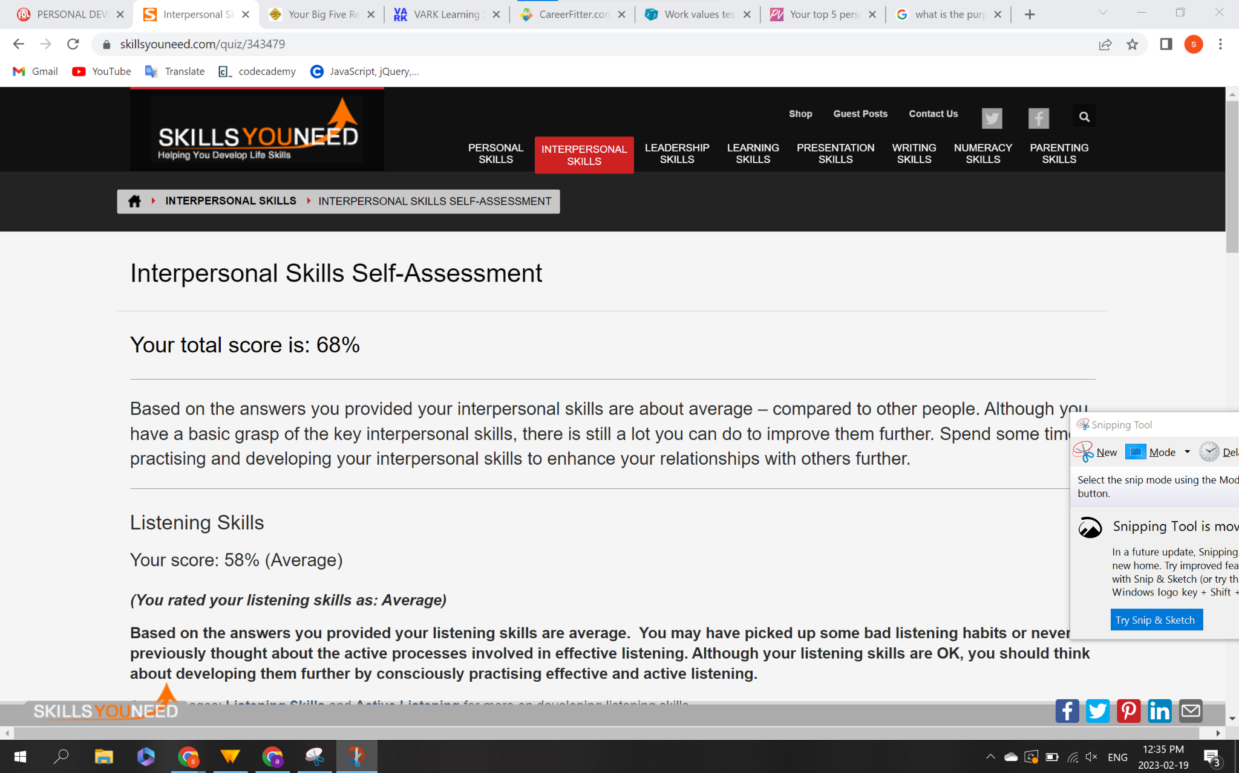

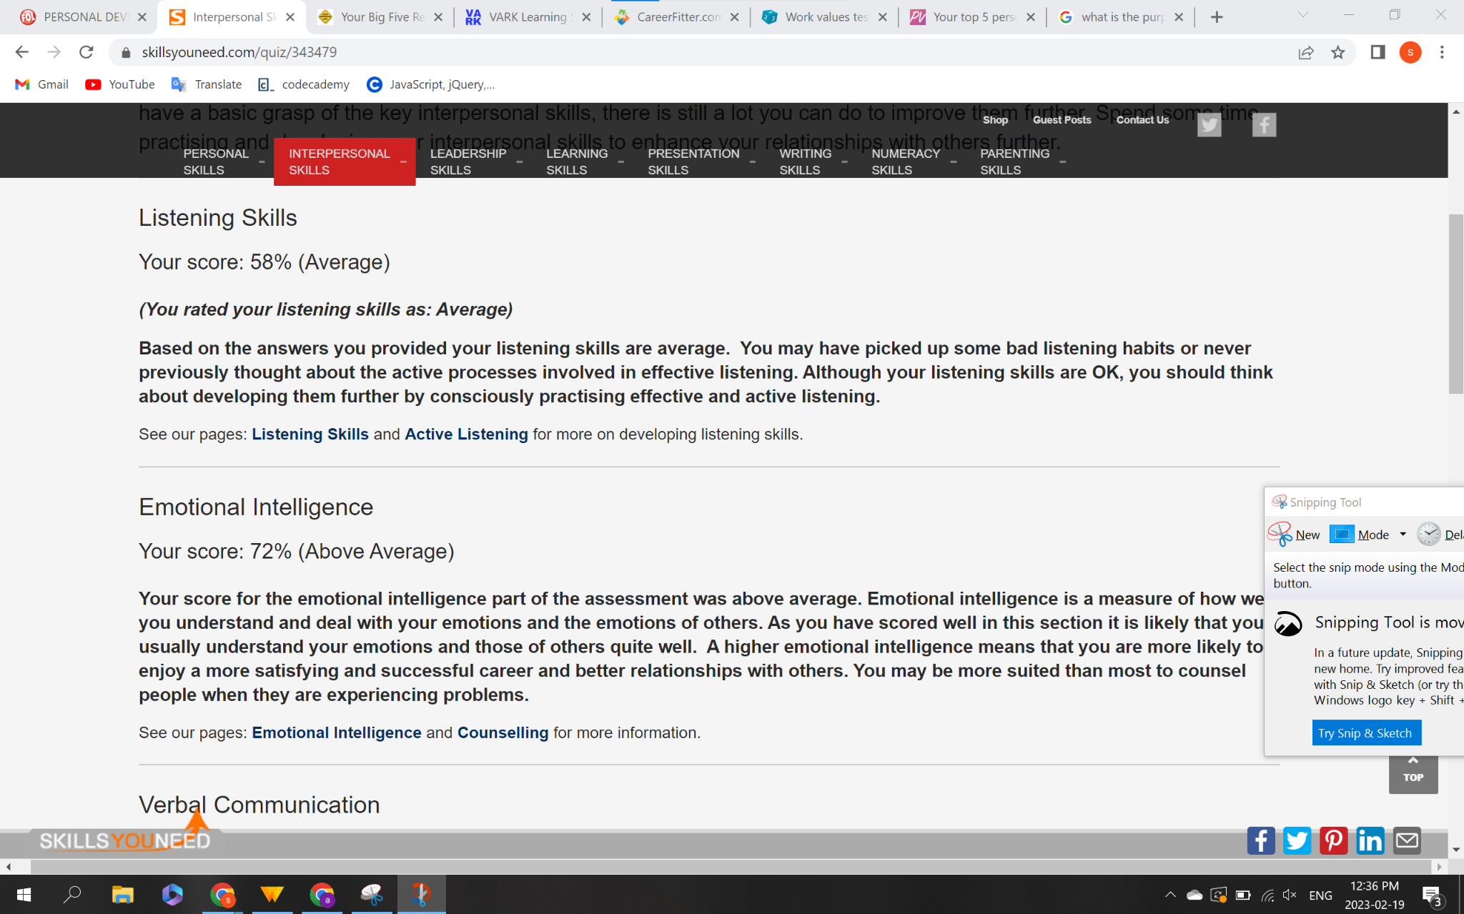

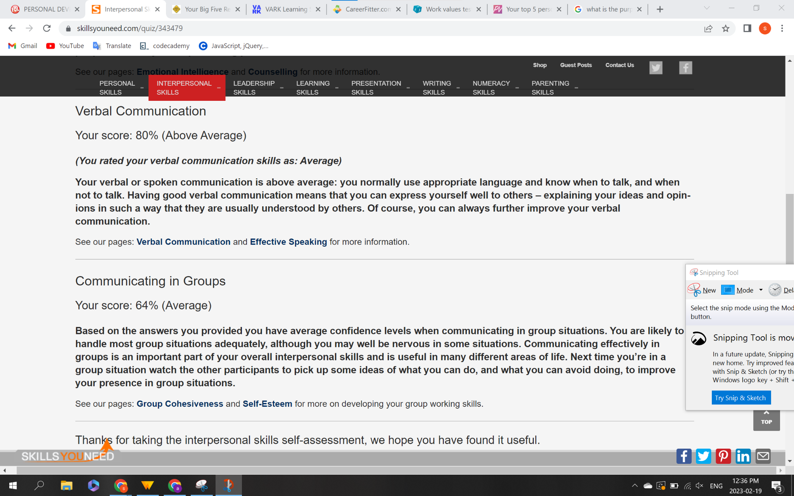

Part C- Summary and Significance

C1) The general similarities that I observed are in two of the assessments, which is the “work personality test” and “the work value test” it connects. For instance, my work personality strength shows that I am creative and can think strategically. At the same time, it indicates that I seek a career that provides independence and diversity, and I have a great strength to generate new ideas, and for the work value test, it shows the same thing: I have high creativity skills and good work value.

C2)

| Strength and description | From which assessment? | Benefit of strength in workplace |
| --- | --- | --- |
| Great Enthusiasm and eagerness | Personal values test | Being excited and curious can attract people. People with this characteristic can strike up a conversation quickly. They can participate in many activities, which is beneficial in the workplace to have a good relationship with colleagues and have a healthy workplace environment. |
| Strategic Thinker | Careerfitter | This is a significant benefit in the workplace because it can help improve critical thinking and allows one to captivate new ideas and make suggestions without hesitating. |
| Creative | Work value test | It is being able to use strong imagination in the workplace. It also helps in developing new ideas and participating in new activities |

C3) Based on the Strength provided in the chart, I am

1. Always eager to learn is a good strength as I am always willing to learn new things and can attract people easily and initiate a conversation. Therefore, it can contribute positively to a healthy workplace environment. It could also help me develop new ideas and activities, which is beneficial.
2. Being a Strategic Thinker can help me become successful in my career path because it can help me approach new challenges and to come up with innovative solutions. Lastly, my field requires a lot of strategic thinking to develop professionally.

C4)

| Weakness and description | From which assessment? | Disadvantage of weakness in workplace |
| --- | --- | --- |
| Listening Skills | Interpersonal skills | Based on the result, I have picked up a bad listening habit which is a significant weakness because it could lead to miscommunications. |
| Communicating in group | Interpersonal skills | I have to be more confident when it comes to communicating in groups, as sometimes, in the workplace, it is essential to share with colleagues. But, on the other hand, if communication is above average, I can become a good team player. |
| Emotional Intelligence | Interpersonal skills | I use my emotional thinking more than following the moral codes, which is a disadvantage because it could lead to not using facts and emotions instead. |

C5) Based on the weaknesses provided in the chart, I am facing some challenges in the workplace related to my interpersonal skills, and the most affected area is.

1. Listening skills- Poor listening skills are a significant disadvantage to me. It can cause miscommunication, and it could lead to issues and misunderstandings. This can result in lowering job performance. For instance, I am currently a student studying programming. If I lack listening skills, it could lead to not being precise, and when it comes to coding, it is essential to carry out every task accurately.
2. Communicating in the group- having average communication skills can strain relationships with co-workers and lead to an unhealthy workplace environment. It also could lower the professional opportunity. Improving communication skills can help build positive working relationships, and after viewing my weaknesses, I seek to improve myself.

C6) One thing I learned about myself after carrying out the “Interpersonal skills assessment” is that I have deficient listening skills. Based on the result, I have picked up bad listening habits. Therefore, at this point, I am concerned and want to improve this weakness to become one of my strengths as I could benefit greatly from it, and it could help me communicate effectively.

References:

(n.d.). *Here is a list of your most important values*. Your top 5 Personal Value. Retrieved February 18, 2023, from <https://personalvalu.es/results/b81c3e89-700c-4dc1-8042-2cf79b1a6f63>

(n.d.). *Work Values test result*. Free Work Value Assessment Test. Retrieved February 18, 2023, from <https://www.123test.com/report/G8YVCLBAIUUCVTKDKQ/>

(n.d.). *Your work personality strengths*. Careerfitter. Retrieved February 18, 2023, from

<https://www.careerfitter.com/free_test/careerbuilder/results>

(n.d.). *The VARK Questionnaire – How do you learn best?* VARK Learning Style Questionnaire. Retrieved February 18, 2023, from <https://vark-learn.com/the-vark-questionnaire/>

(n.d.). *The Big Five Project Personality Test*. Your Big Five Results. Retrieved February 18, 2023, from <https://www.outofservice.com/bigfive/results/?o=50,69,63&c=56,75,69&e=69,100,69&a=63,94,75&n=50,13,38&y=2000&g=f>

(n.d.). *Interpersonal Skills Self-Assessment*. Interpersonal Skills Self-Assessment. Retrieved February 18, 2023, from https://www.skillsyouneed.com/quiz/343479